

User Guide

Administration tool – Kalima Explorer

Table of Contents

Table of Contents 1

1 - Overview of the Kalima Explorer Administration Tool 2

2 - Authentication 2

3 - Cache Path tab 3

4 - Memcaches explorer tab 5

5 - Blockchain explorer tab 8

5.1 - Sorting by sequence 9

5.2 - Sorting by date 10

5.3 - Navigating between pages in a path cache 12

Contacts Kalima Systems 12

# Overview of the Kalima Explorer Administration Tool

The Kalima Explorer administration tool allows the management of data shared with authorized nodes of the blockchain. All its actions are historicalized to add security and traceability to the data. Data history cannot be modified or deleted.

This administration tool offers several features including sorting and searching functions in saved data and the management of permissions, users, configurations.

# Authentication

When you access Kalima Explorer, you must authenticate:

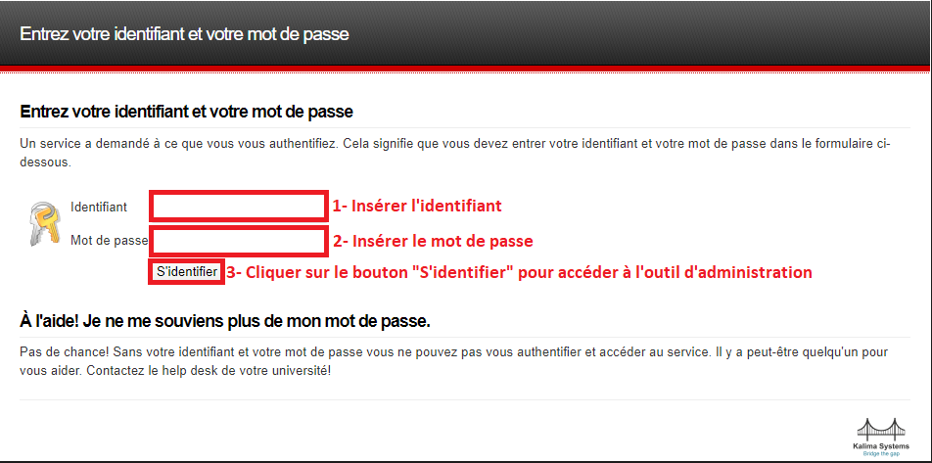 *Figure 1 – Authentication to the Kalima Explorer Administration Tool*

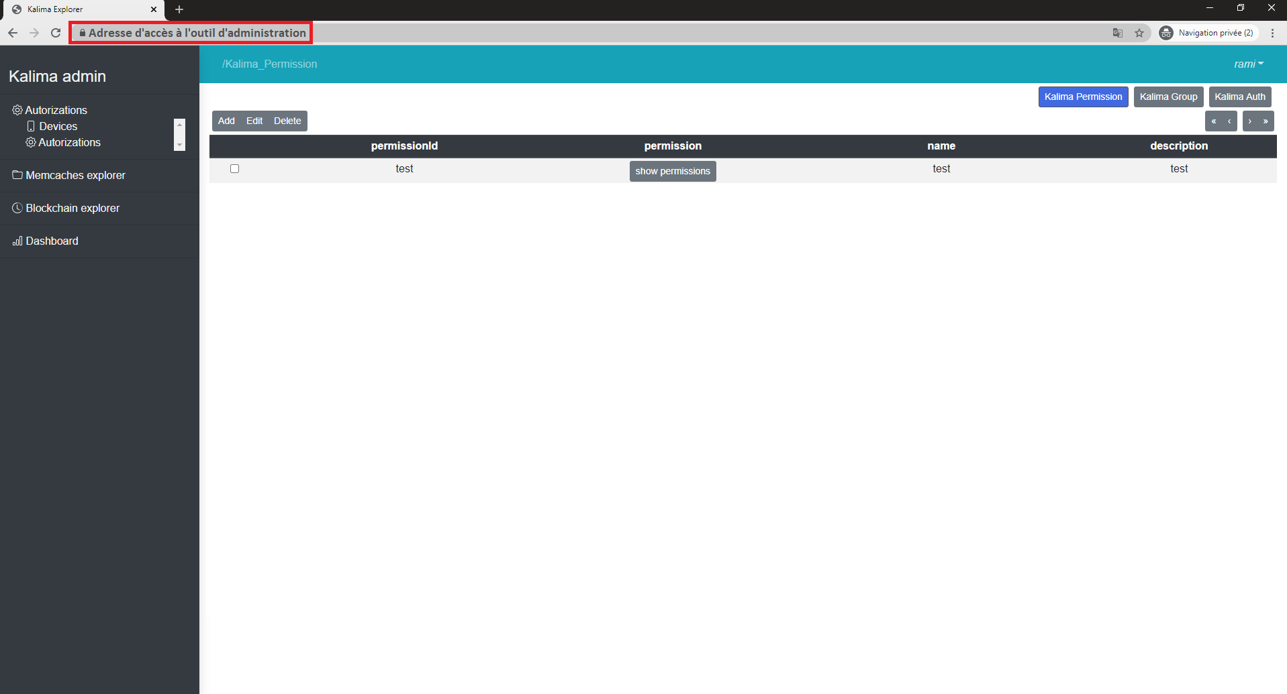Once authenticated you will have access to the following home page of the Kalima Explorer administration tool:

*Figure 2 – Kalima Explorer Administration Tool Home Page*

To log out of the Kalima Explorer administration tool, click on the username at the top right of the screen and make "Logout".

In the menu located on the left of the screen you have a list of tabs, each of these tabs integrates sub-tabs and / or a set of paths caches.

Remark:

To organize the data in the Kalima blockchain, we use path caches. This can be seen as a file system with folders and files that will contain the data.

# Cache Path tab

To create a transaction in the Kalima blockchain it is necessary, in addition to useful data and identity data, to specify an address.

In fact, each transaction is placed in a database that can be seen as a file system. The Cache path / address simply corresponds to the path on which we want to store our transaction. The Notary govern the possible paths, it is not possible to create a transaction with ane address that does not exist.

The creation of a new address in the Kalima blockchain is done in a dynamic way, it is possible thanks to the Kalima Explorer administration tool. To add a new address you can follow the steps below:

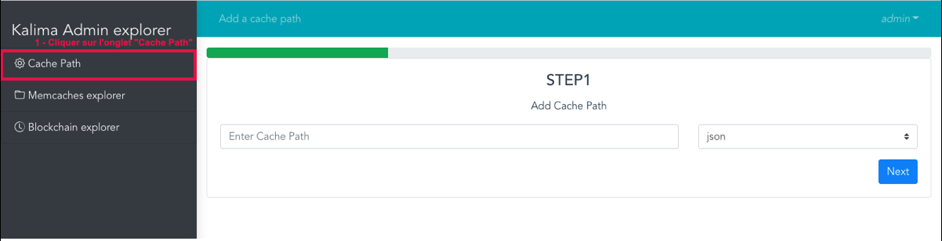

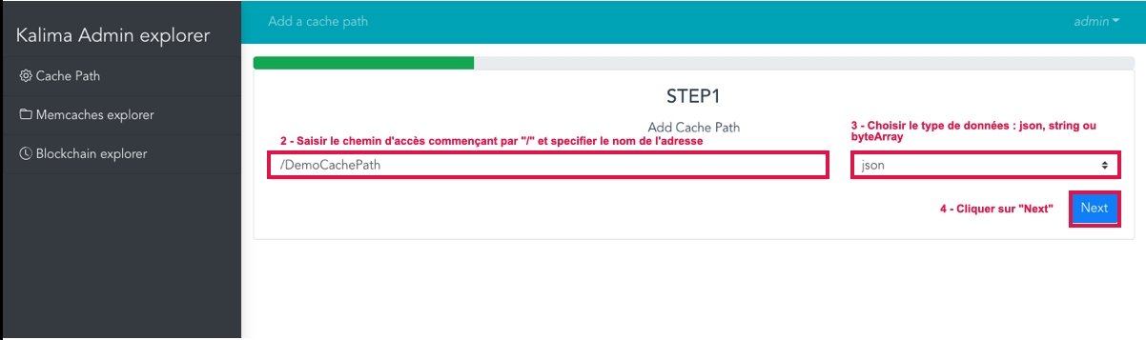

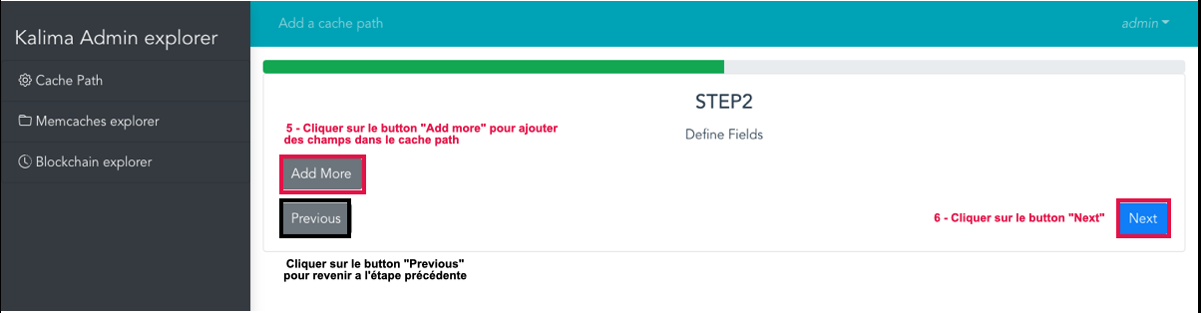

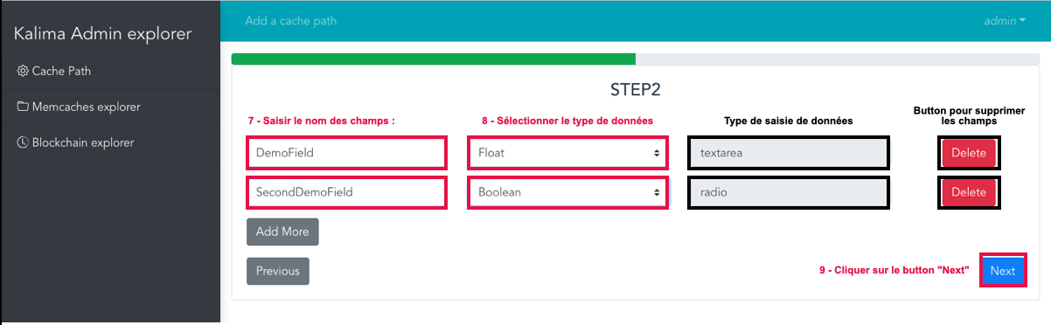

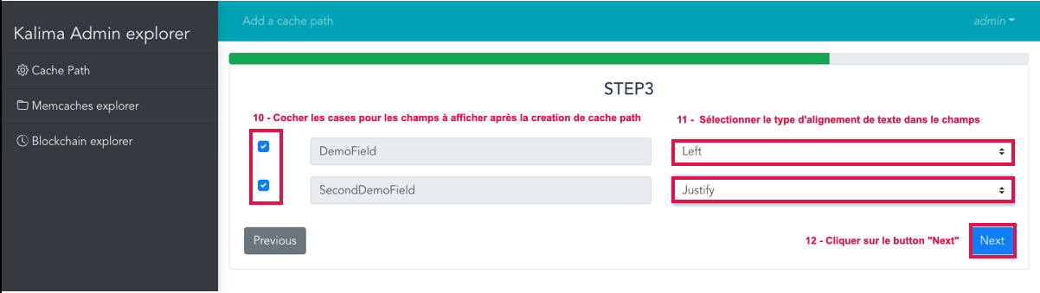

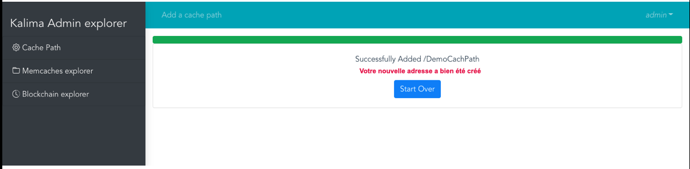

*Figure 3 – Steps to create a new address*

# Memcaches explorer tab

Kalima "caches" contain all current data and are shared between all nodes of the Blockchain (according to permissions).

The data in caches can be modified, deleted, new ones can be added. However, each action corresponds to a new transaction, and is therefore registered in the blockchain. In addition, it is possible to perform search operations on the data of an address in the Memcaches explorer tab.

In the Memcaches explorer tab of the Kalima Explorer administration tool, the most recent data is displayed at the top and the least recent data is displayed at the bottom of each page.

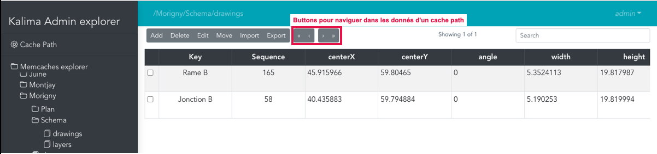

*Figure 4 – Buttons to navigate through the data of an address*

**Buttons navigation between data pages:**

There are 4 buttons (top right) that allow you to navigate through the data:

- Button to move to the next data page,

- Button to return to the previous data page,

- Button to return to the first page of data,

- Button to display the last page of data.

**Creating new data:**

To create a new data you can follow the steps below:

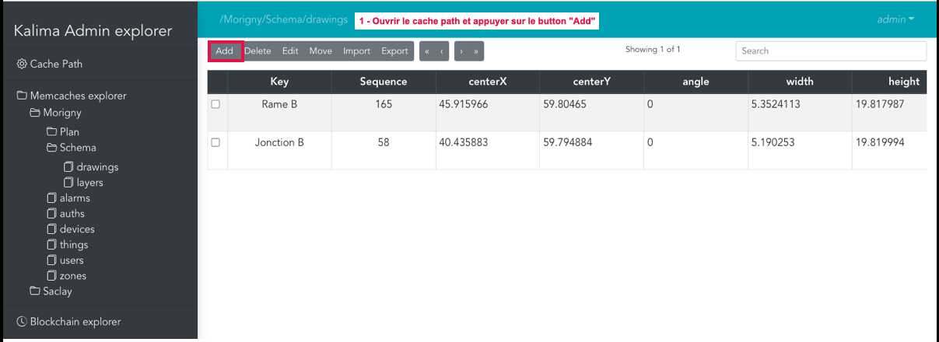

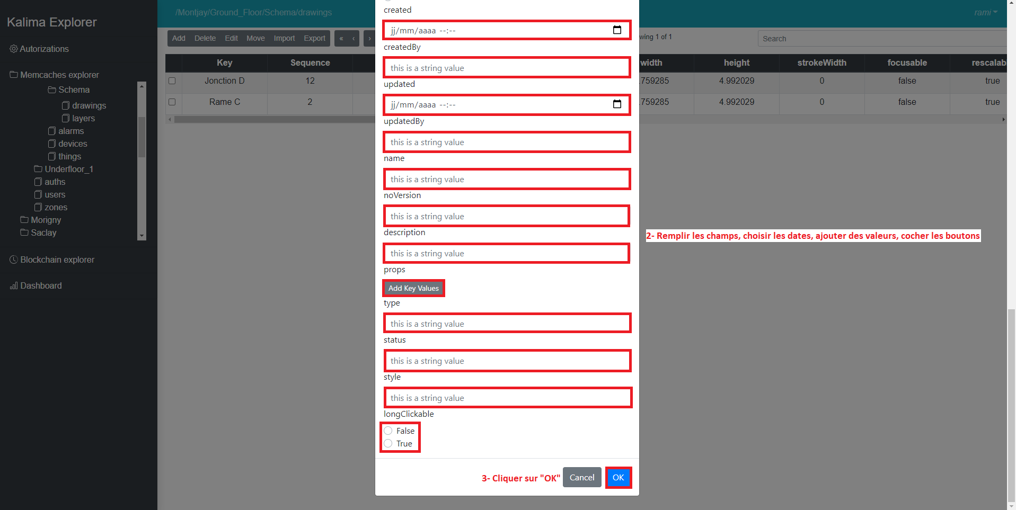

*Figure 5 – Steps to add data within an* *address*

Remark:

* Each path/address cache has its own fields, so for the creation of a new data in a specifice address e, you must fill in the fields displayed in the pop-up.

**Modification of a data**

Once created, a data can be modified. To make this change you can follow these steps:

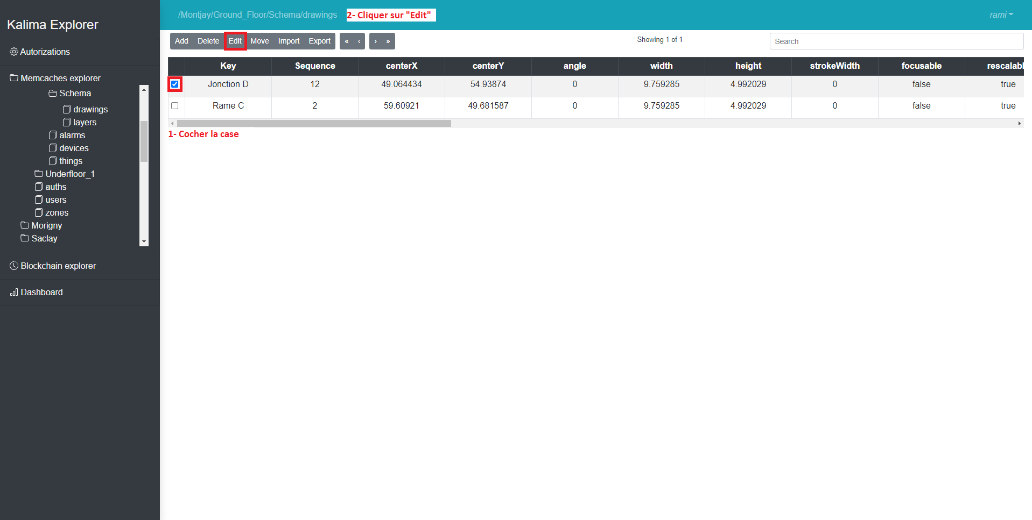

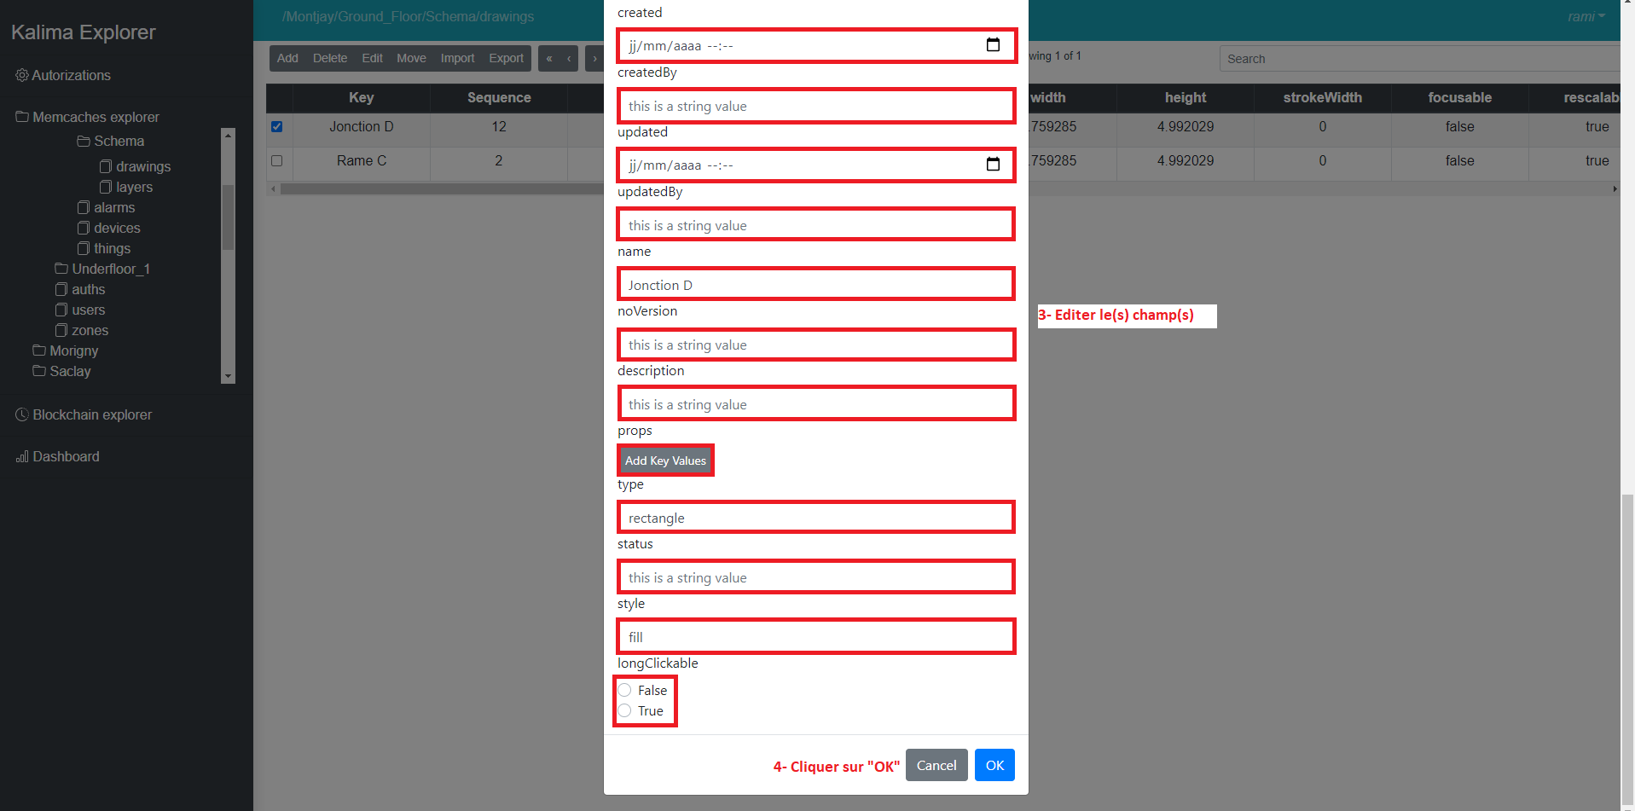

*Figure 6 – Steps to change data in an address*

**Delete data**

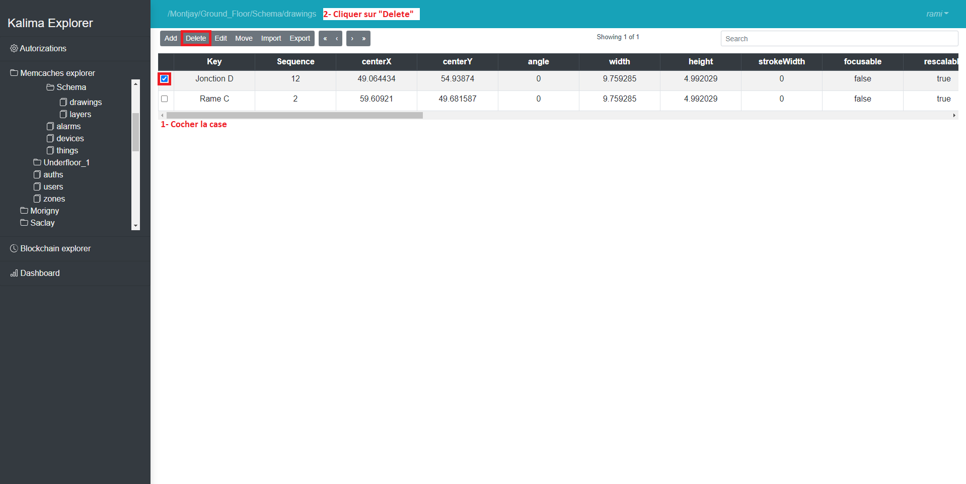To remove data from the Memcaches explorer tab you can follow these steps:

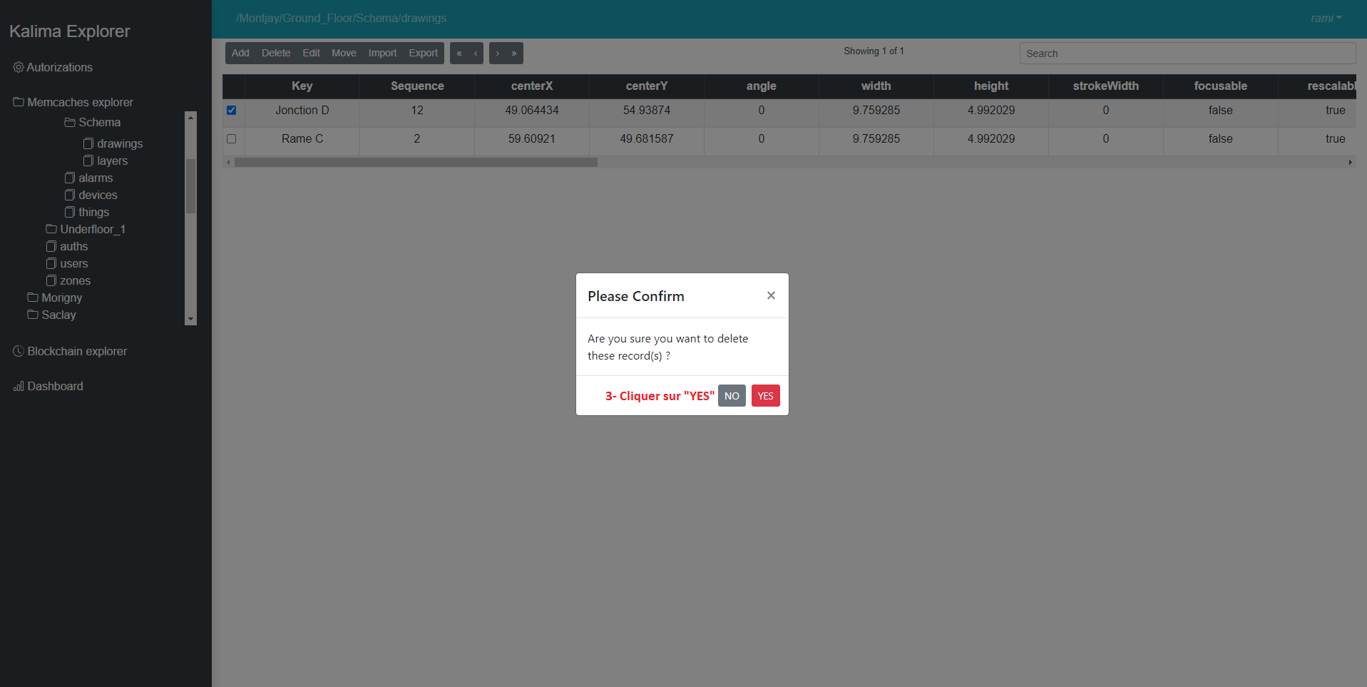

*Figure 7 – Steps to delete data*

**Searching for data**

To search for data in anaddress, you can use the search bar and enter a keyword of the data to be searched. Here is an example of searching for a piece of data:

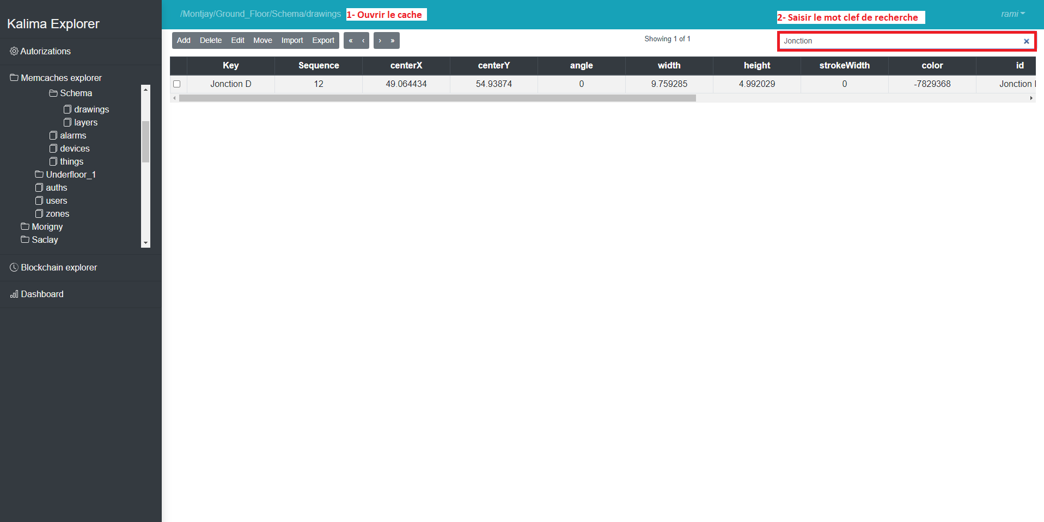*Figure 8 – Steps to search for data by keywords*

# Blockchain explorer tab

The "Blockchain explorer" tab contains absolutely all the data of the Kalima blockchain. One can see all the transactions that have taken place on the Blockchain, including data deletions.

This tab offers several features including sorting data by sequence, sorting by date, sorting by criteria.

In the Blockchain explorer tab of the Kalima Explorer administration tool, the most recent data is displayed at the top and the most recent data is displayed at the bottom of each page.

## Sorting by sequence

Each transaction has a unique sequence number.

The Kalima Explorer administration tool offers the possibility to apply a data sorting filter between two precise sequences using the "By sequence" button. To sort by sequence you must follow the steps below:

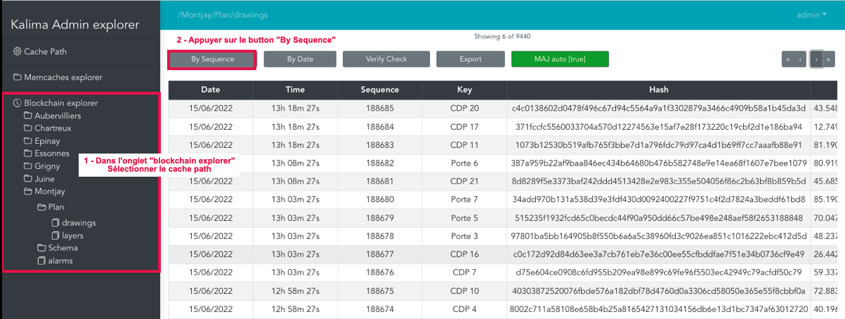

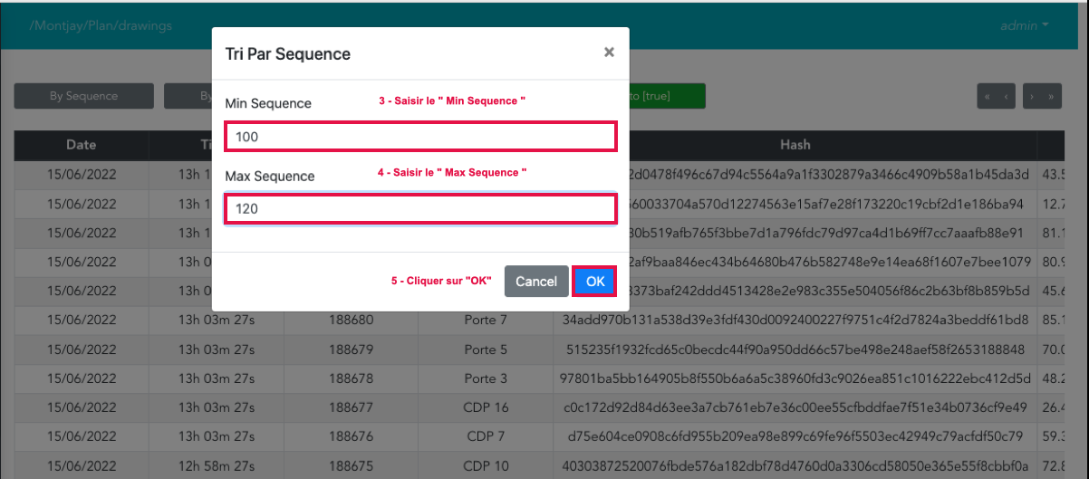

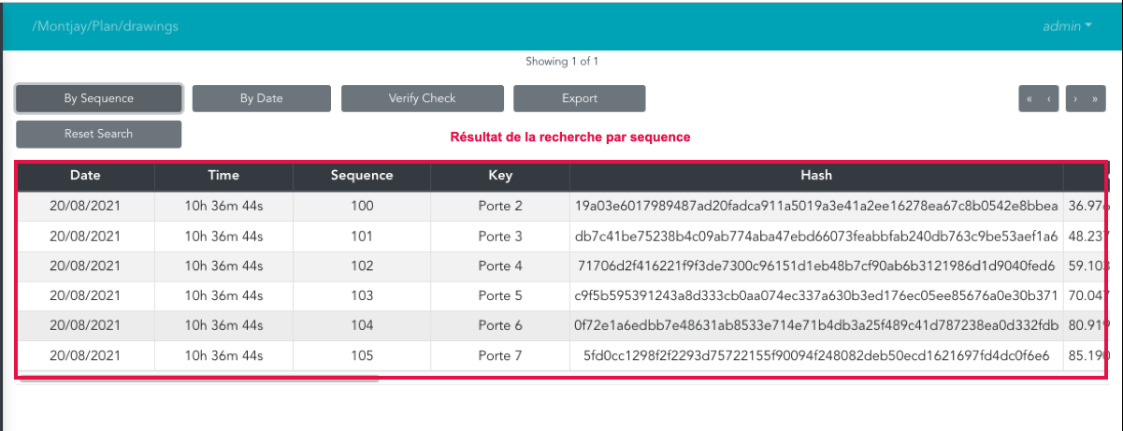

*Figure 9 – Steps to sort data by sequence*

To redisplay all the data present before the sequence sorting application, simply click on the "Reset Search" button:

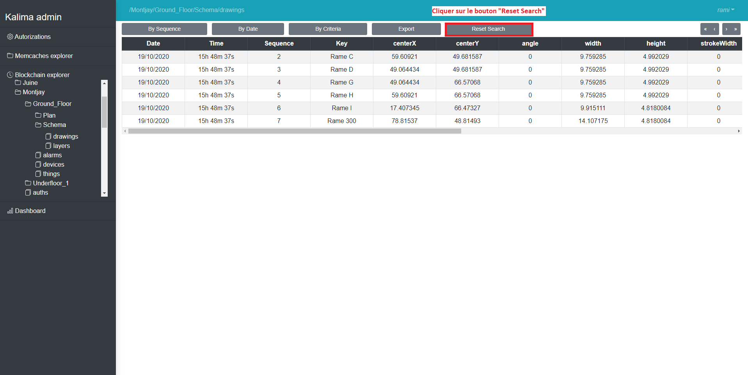

*Figure 10 – “Reset Search” button*

## Sorting by date

Each transaction has a specific date and time.

The "By Date" button is used to display the data between two dates. These dates can be selected thanks to a calendar that is displayed at the press of the button. The calendar also gives the possibility to choose time slots for the data to be displayed:

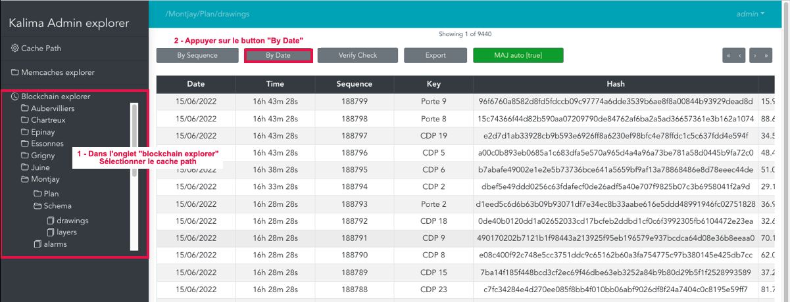

An image containing text

Auto-generated description

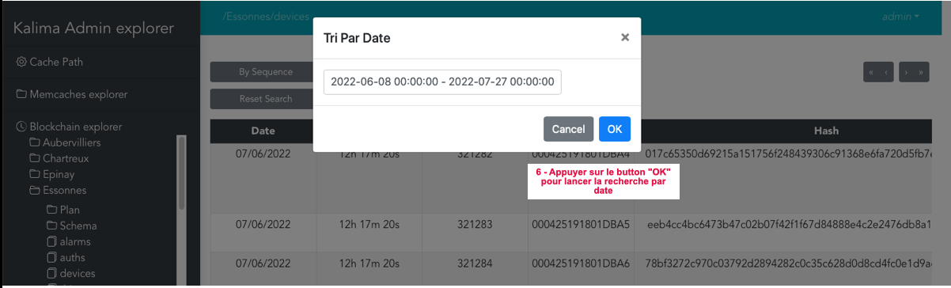

*Figure 11 – Steps to sort data by date*

Similarly for the sorting function by date, to redisplay all the data present before the date sorting application, simply click on the "Reset Search" button.

Remark:

It is possible to choose the same date to mark the beginning and end of the data search while specifying the start and end times.

## Navigating between pages in a path cache

As is the case for the other tabs, the "Blockchain explorer" tab contains buttons allowing navigation between data pages. These buttons have the same functioning as other tabs.

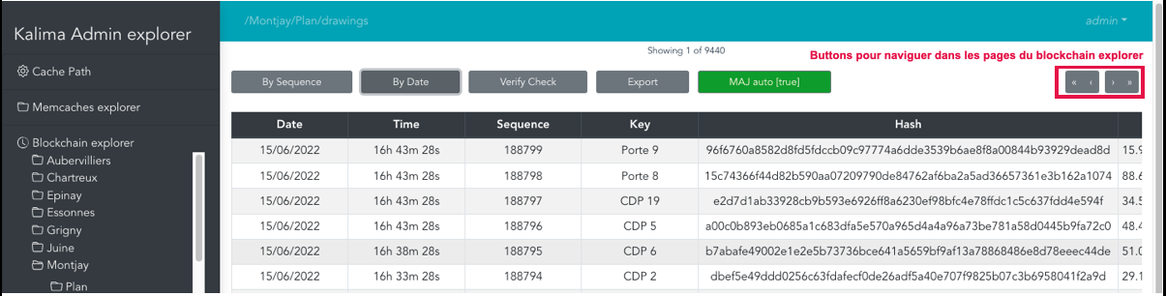

*Figure 12 – Navigation buttons between Blockchain Explorer pages*

# Contacts Kalima Systems

Address

66 Avenue des Champs-Elysées

75008 Paris, France

Mobile and Email

Jerome DELAIRE – jerome.delaire@kalima.io

+33(0)6 73 84 95 52

Website

[www.kalima.io](http://www.kalima.io)



**Thank you**